**Mental Health Awareness Quiz**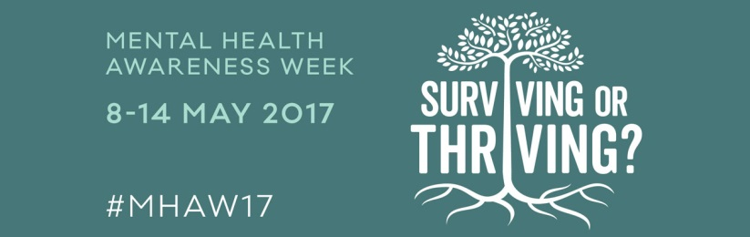

1. How many people will experience some sort of mental health problem in their lifetime?
2. 1 in 4
3. 1 in 3
4. 1 in 10
5. 1 in 18

# What portion of people with a known mental disorder will seek professional help?

# About 1/2

# About 1/3

# About 3/4

# About 1/5

# Are men or women more likely to have been treated for a mental health problem?

# Women

# Men

# Equally likely

# What is the largest provider of mental health care in the US?

# Private hospitals

# Jails and prisons

# Private practice

# State-run psychiatric facilities

# What percentage of adults with diagnosable mental health problems receive needed treatment?

# 38%

# 72%

# 14%

# 48%

# What percentage of children with diagnosable mental health problems receive needed treatment?

# 10%

# 20%

# 30%

# 40%

# Do children ‘grow out’ of mental health problems?

* 1. Yes - most children experience difficult periods, but most issues fade with age.
  2. Yes - mental illness is significantly over-diagnosed in children.
  3. No – nearly all mental health disorders manifest before age 12.
  4. No - half of all mental health disorders show first signs before a person turns 14 years old, and three quarters of mental health disorders begin before age 24.

# Which of the following behaviours exhibited by an adult does NOT require urgent attention?

* 1. Short-term irritability or restlessness
  2. Thoughts or plans of killing or hurting one’s self or another person
  3. Hearing voices or seeing things that no one else can hear or see
  4. Sudden personality changes that are bizarre or out of character

# What is mindfulness?

* 1. Emptying your mind of thoughts through meditation
  2. ‘Zoning out’
  3. Paying attention to the present moment without judgment or worry
  4. Being aware of the minutia of the present and analysing each component

1. Is it possible to prevent mental illness?
   1. Yes, with meticulous care down to timing of a child’s birth and selection of a reproductive partner.
   2. To an extent, though prevention focuses on addressing known risk factors such as exposure to trauma.
   3. No, susceptibility of mental illness is entirely determined by biology and genetics.

Answers:

1. a – 1 in 4
2. b – 1/3
3. a – women 29% of women compared to 17% of men
4. b – prisons
5. a – 38%
6. b – 20%
7. d
8. a
9. c
10. b